**Industrial Internship Report on**

**” Prediction of Agriculture Crop Production in India”**

**Prepared by**

**Jerom Kurian**

|  |
| --- |
| *Executive Summary* |
| This report provides details of the Industrial Internship provided by upskill Campus and The IoT Academy in collaboration with Industrial Partner UniConverge Technologies Pvt Ltd (UCT).  This internship was focused on a project/problem statement provided by UCT. We had to finish the project including the report in 6 weeks’ time.  My project was My project was Prediction of Agriculture Crop Production in India. . Crop volume prediction is an important aspect of agriculture that helps farmers make informed decisions about their crops. It involves estimating the volume of crop that will be produced in a given area based on various factors such as columns such as year, Area,state,crop. In recent years, machine learning (ML) has emerged as a powerful tool for predicting crop yields. . Machine learning is a branch of artificial intelligence (AI) that allows computers to learn from data without being explicitly programmed. This makes it ideal for crop volume prediction because it can identify patterns and relationships in large amounts of data and make predictions based on these relationships.  This internship gave me a very good opportunity to get exposure to Industrial problems and design/implement solution for that. It was an overall great experience to have this internship. |

**TABLE OF CONTENTS**

1 Preface 3

2 Introduction 5

2.1 About UniConverge Technologies Pvt Ltd 5

2.2 About upskill Campus 9

2.3 Objective 11

2.4 Reference 11

2.5 Glossary **Error! Bookmark not defined.**

3 Problem Statement 11

4 Existing and Proposed solution 12

5 Proposed Design/ Model 13

5.1 High Level Diagram (if applicable) **Error! Bookmark not defined.**

5.2 Low Level Diagram (if applicable) **Error! Bookmark not defined.**

5.3 Interfaces (if applicable) **Error! Bookmark not defined.**

6 Performance Test 15

6.1 Test Plan/ Test Cases 15

6.2 Test Procedure 15

6.3 Performance Outcome 15

7 My learnings 15

8 Future work scope 16

# Preface

The Data science and machine learning internship duration was of 6 weeks. 1st week of the internship was to explore the problem statement which were provided by the management and understand their background in order to start with the project. Also learned about UCT. 2nd week of the internship was to understand and follow the project instructions provided by UCT. And, also to plan for the solution of the existing problem. 3rd week of internship is to start for the actual working of the project. 4th week of the internship was so to continue with the work on the project and check whether there are improvements required for the project. 5th week of the internship was to validate your implementation and evaluate your performance. And the final week of the project is to submit your project report and get certification. Internships are an opportunity to network with great people and sharpen your skills before entering the workforce. They also help tremendously with figuring out your true passion. Companies often look at them as a way to gain experience and exposure to make a smooth transition into your role when hired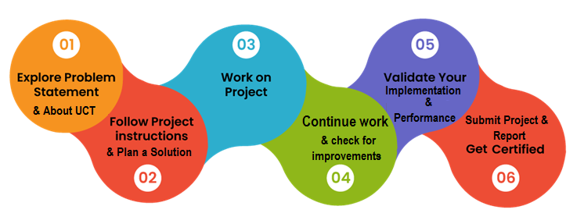

Agriculture is the main occupation for the people of India, covering 60% of the nation land and catering the basic needs of 1.2 billion people. For the benefit of the farmers, modernization of agriculture procedures is carried out today. Now a days data mining, machine learning as well as deep learning approaches are used by various researchers to enhance and improve the volume of crop and their quality. Machine Learning can gain proficiency with the machine without characterized computer programming, so it improves machine execution by distinguishing and portraying the consistency and pattern of drive information. In this work various machine learning approaches such as Linear Regression, Gradient Boosting Regressor, Random Forest Regressor, Decision Tree Regressor, Polynomial Regression, Ridge Regression have been used for volume prediction on crop dataset of different states and considering varied crops. This internship gave me a very good opportunity to get exposure to Industrial problems and design/implement solution for that. It was an overall great experience to have this internship.

Your Learnings and overall experience.

Thank to Upskill campus, who have helped me through videos and books provided.

# Introduction

## About UniConverge Technologies Pvt Ltd

A company established in 2013 and working in Digital Transformation domain and providing Industrial solutions with prime focus on sustainability and RoI.

For developing its products and solutions it is leveraging various**Cutting Edge Technologies e.g. Internet of Things (IoT), Cyber Security, Cloud computing (AWS, Azure), Machine Learning, Communication Technologies (4G/5G/LoRaWAN), Java Full Stack, Python, Front end**etc.

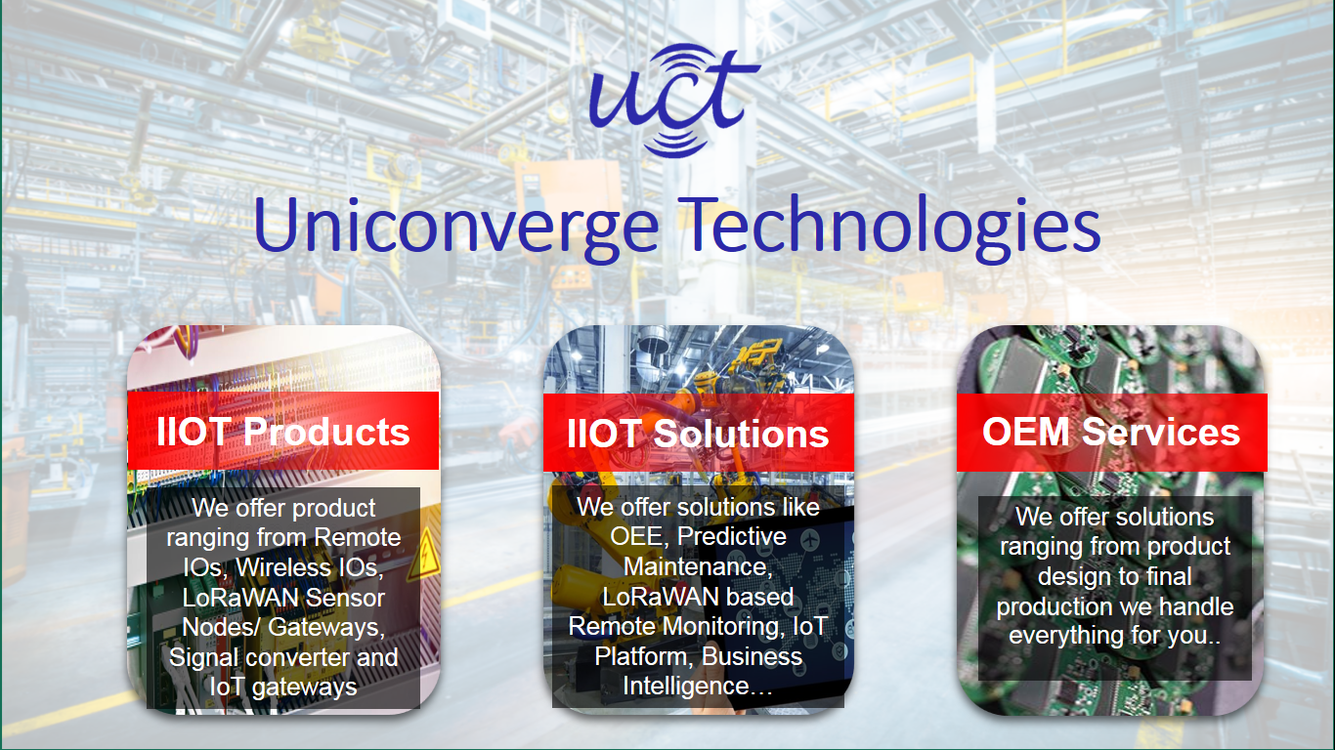

1. UCT IoT Platform **(****)**

**UCT Insight** is an IOT platform designed for quick deployment of IOT applications on the same time providing valuable “insight” for your process/business. It has been built in Java for backend and ReactJS for Front end. It has support for MySQL and various NoSql Databases.

* It enables device connectivity via industry standard IoT protocols - MQTT, CoAP, HTTP, Modbus TCP, OPC UA
* It supports both cloud and on-premises deployments.

It has features to  
• Build Your own dashboard  
• Analytics and Reporting  
• Alert and Notification  
• Integration with third party application(Power BI, SAP, ERP)  
• Rule Engine

 

1. **Smart Factory Platform (****)**

Factory watch is a platform for smart factory needs.

It provides Users/ Factory

* with a scalable solution for their Production and asset monitoring
* OEE and predictive maintenance solution scaling up to digital twin for your assets.
* to unleased the true potential of the data that their machines are generating and helps to identify the KPIs and also improve them.
* A modular architecture that allows users to choose the service that they what to start and then can scale to more complex solutions as per their demands.

Its unique SaaS model helps users to save time, cost and money.

 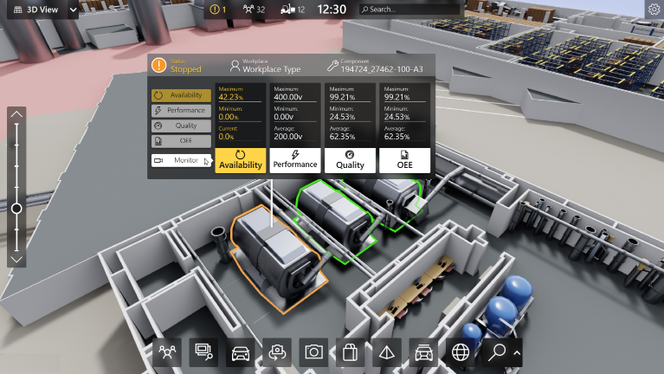

1.  based Solution

UCT is one of the early adopters of LoRAWAN teschnology and providing solution in Agritech, Smart cities, Industrial Monitoring, Smart Street Light, Smart Water/ Gas/ Electricity metering solutions etc.

1. Predictive Maintenance

UCT is providing Industrial Machine health monitoring and Predictive maintenance solution leveraging Embedded system, Industrial IoT and Machine Learning Technologies by finding Remaining useful life time of various Machines used in production process.



## About upskill Campus (USC)

upskill Campus along with The IoT Academy and in association with Uniconverge technologies has facilitated the smooth execution of the complete internship process.

USC is a career development platform that delivers **personalized executive coaching** in a more affordable, scalable and measurable way.



Seeing need of upskilling in self paced manner along-with additional support services e.g. Internship, projects, interaction with Industry experts, Career growth Services

<https://www.upskillcampus.com/>

upSkill Campus aiming to upskill 1 million learners in next 5 year

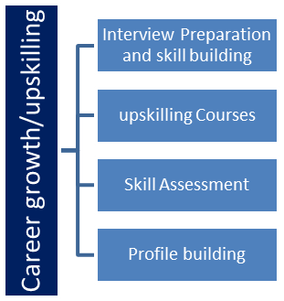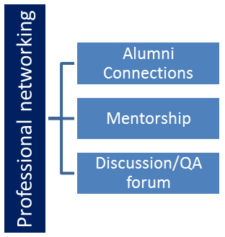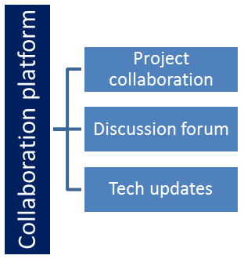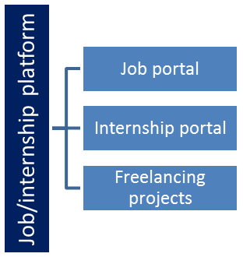

## The IoT Academy

The IoT academy is EdTech Division of UCT that is running long executive certification programs in collaboration with EICT Academy, IITK, IITR and IITG in multiple domains.

## Objectives of this Internship program

The objective for this internship program was to

 ☛ get practical experience of working in the industry.

 ☛ to solve real world problems.

 ☛ to have improved job prospects.

 ☛ to have Improved understanding of our field and its applications.

 ☛ to have Personal growth like better communication and problem solving.

## Reference

[1]produce.csv

[2]datafiles.csv

[3] Final_data.csv (New data produced from produce.csv)

# Problem Statement

In the assigned problem statement

Agriculture is one of the main sources of income in India. There is need to improve the sustainability of agriculture with the rate of increase in suicides of farmer due to crop failure and less volume and losses. Hence, it is a significant contribution towards the economic and agricultural welfare of the countries across the world. The Problem Statement revolves around prediction of volume of crops considering different states of India including various attributes. Goal of this project is to help the farmers to choose the suitable crop to grow in order to get the required volume and the profit. Need for the crop volume prediction is very much essential at this point of time for selecting the right crop

# Existing and Proposed solution

**Existing Solution**

In case of crop area determination, both subjective and objective methods are currently adopted to collect volume statistics in various countries. The subjective methods of estimating crop volume include farmers’ assessments, expert opinions and crop cards, while the objective methods include whole-plot harvesting and crop-cutting experiments. The practice of sowing crops in mixture in a single parcel of land is prevalent in many countries, particularly where land holdings are small. The growing of crops in mixtures is a common practice because it protects farmers from adverse 10 weather conditions such as drought, flood, and pest and disease infestation. Further, it enables maximal utilization of the space, moisture and nutrients available in the field. Cultivators usually mix crops that cannot withstand a particular type of weather with another set of crops that thrive under those same conditions.

**Proposed Solution**

In this 21st century, it is very common to experiment in every sector by implementing new technological techniques. Making use of new techniques simplifies the process and provides the better results. The factors like wind, water supply, soil fertility, rainfall changes unexpectedly, when natural disasters occur. This leads to crop failure, reduction in crop production, scarcity of food products and other materials. A single crop failure can cause huge losses to farmers and countries economic growth. So, there is a desperate need for a new system which can predict the rate of production of crop yield accurately. In order to eradicate all such problems, we have proposed this new system, in which high yielding crop will be selected by considering most influencing parameters. This system helps the farmers to meet their crop volume production. The chances for failure of crops will be very less. In this proposed system, Machine Learning techniques like Random Forest Regressor and Decision Tree Regressor are made used to predict the volume of crop produced considering the input parameters like State Name, Area, Crop.

## Code submission (Github link) : [Prediction of Agriculture Crop Production in India.ipynb](https://github.com/JK1Real/Upskillcampus/blob/main/Prediction%20of%20Agriculture%20Crop%20Production%20in%20India.ipynb)

## If by chance above link doesnot work

## <https://github.com/JK1Real/Upskillcampus/blob/main/Prediction%20of%20Agriculture%20Crop%20Production%20in%20India.ipynb>

## Report submission (Github link) : [Prediction of Agriculture Crop Production in India_Jerom__USC_UCT.pdf](https://github.com/JK1Real/Upskillcampus/blob/main/Prediction%20of%20Agriculture%20Crop%20Production%20in%20India_Jerom__USC_UCT.pdf)

## If by chance above link doesnot work

## <https://github.com/JK1Real/Upskillcampus/blob/main/Prediction%20of%20Agriculture%20Crop%20Production%20in%20India_Jerom__USC_UCT.pdf>

# Proposed Design/ Model

Given more details about design flow of your solution. This is applicable for all domains. DS/ML Students can cover it after they have their algorithm implementation. There is always a start, intermediate stages and then final outcome.

Test data pred (Fold 1)

Fold 2

Avg. Pred Results

Test data Pred (Fold 2)

Split Data into K Equal Folds

Fold 1

Choose k of Folds

Load & Preprocess Data

Fold k

……………

Test data pred (Fold k)

…………

## In this project, the system makes use of the Machine Learning techniques to predict rate of crop Production. The programming language used is Python as it is widely accepted for new idea implementations in the field of Machine Learning. In this project, collected data set will be uploaded and prediction for crop production will be generated by applying Machine Learning techniques like Random Forest Regressor and Decision Tree Regressor etc. The results depend on the information present in the collected data set. Accurate the information about the parameters in the collected datasets, better the results will be.

# Performance Test

## Test Plan/ Test Cases

Returns the predicted production of crops based on the user's input. If the user wants to know the production of a particular crop, the system takes the crop as the input as well. Else, it returns a list of crops along with their production as output.

## Test Procedure

* Step 1: First make sure the user have accurate data
* Step 2: Takes State, crop, Area of cultivation, year of cultivation as inputs. These values are given as input to the model implementation in the backend and the corresponding predictions are returned. The algorithm returns a list of crops along with their production predicted.

## Performance Outcome

In the final implementation of the application the first screen the user can view is the login page. Here, the user can register or login using his/her credentials into the application.

1. The system takes the required inputs to predict the production of crop.
2. The user can provide data about new crops and data for future use by which new models can be trained for future purpose and can also produce monetary benefits from other users who have used if the model gets useful for them

# My learnings

Studied the basics of data science and its applications. Studied about machine learning in depth. Glanced through the instructions of the internship program and understood the process. Went through the profile of UCT. Selected the project for the machine learning internship. Project Category: A. Agriculture, Project No. 4 Prediction of Agriculture Crop Production In India. Studied the various problems faced by farmers of India during Crop production. Went through the data of the crop production. Read and understood the basic concepts from the e-book Introducing-Data-Science-Machine-Learning. Glanced through the Impact-Of-Big-Data-On-Business and understood what is Big Data and its applications. Studied the difference between a Data scientist and the Data Analyst and how they contribute towards the project. Attempted the Quiz to test my intellectual capability. Gathered the information of Artificial Intelligence and Data Science and also understood the difference between the both. Learned how to map your career path with help of artificial intelligence and data science. Learnt about the skills which are required for artificial intelligence or data science or big data or machine learning engineer. Hence came to a conclusion that artificial intelligence and data science are inter-connected. So, specialization in either field requires a working knowledge of the other. To begin using ML-AI, studying data analysis is more necessary than understanding data science. Glanced through the introduction of Probability and statistics and revised the concepts of sample spaces, random variables, probability of an event, discrete c.r.v., probability distribution, other special distributions, large sample theory, parametric point estimation, etc. Learned what are the technical and non-technical skills required for a data scientist. The Top 5 Skills Crucial for Becoming A Data Scientist are Programming, Statistics and Mathematics, Machine Learning, Deep Learning and Big Data. Having a knowledge and expertise in these skills is essential for an ideal data scientist.

# Future work scope

This system is proposed to deal with the increasing rate of farmer suicides and to help them to grow financially stronger. The site can be modified as much more useful tool for farmers as well

As data scientist. We can monetize the data provided from farmers of unknown crop for future, where by which if we make the data open for

Other data scientist around the world and from which the if other farmers got the model useful and if want to contribute the money it can be distributed both to the data scientist as well as the farmer which helped by giving the data about the new crop.

We can also conduct competitions by pairing a farmer with data scientist by checking which one got more accurate in prediction which can help in the growth of agriculture in India.